**GOVERNMENT ARTS ,COMMERCE & BED COLLEGE, KACHHAL**

**AT:KACHHAL, PO:KARCHELIYA, TA: MAHUVA, DIST.: SURAT, 394240**

**(Permanent Affiliated to Veer Narmad South Gujarat University, Surat)**

**NAAC ACCREDIATED: GRADE-C**

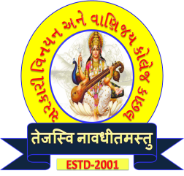

**Principal**

**Dr. Hetal S. Tandel**

**GES Class - 1**

**Mo. No. 98792 96636**

**Email: gacckachhal@gmail.com**

**Web Site:http://www.kachhalcollege.org/**

**INTERNAL QUALITY ASSURANCE CELL**

**AGENDA FOR IQAC MEETINGS TO BE HELD DURING THE YEAR 2021-22**

To,

All the IQAC Members are requested to go through the agenda set for IQAC meeting no. 2 to be scheduled on September 28, 2021 at 01:30 pm in the Principal’s office..

**Agenda:**

1. Review of term-wise activities to be conducted
2. Collection of activity reports
3. Review of Academic Calendar
4. Proposal to conduct subject-wise seminars
5. To invite proposals for implementing Best Practices
6. Proposal to provide financial support to faculty members for attending seminars and conferences.
7. Status of AQAR report for 2020-2021
8. Matters related to RUSA and non-governmental expenses
9. Discussion and planning any other matter with the permission of the chairperson.

Kindly make it convenient to attend the meeting.

Dr. Dhvani B. Desai Dr. Hetal S. Tandel

(Coordinator) (Chairperson & Principal)