GOVERNMENT ARTS & COMMERCE COLLEGE, KACHHAL
REPORT ON ONE-DAY NATIONAL WORKSHOP ON INTELLECTUAL PROPERTY RIGHTS AND INNOVATIONS IN HIGHER EDUCATION POLICY
A.Y. 2021-22
A One-day national workshop on IPR and Innovations in Higher Educational Policy was organized by IQAC and SSIP, Government Arts & Commerce College, Kachhal on October 26, 2021.
The workshop was focused on giving a general idea on the concept and importance of IPR, especially to rural students who may have the opportunity to convert their jugaad ideas into patents and develop a career out of their rightful inventions, in the first technical session held by Dr. Vijeta S. Singh (Asst. Professor of Law, S. S. Maniyar Law College, Jalgaon, Maharashtra) as the resource person.
The second technical session was conducted by Dr. Mehul G. Thakkar (Asso. Professor of HRM, Navsari Agricultural University, Navsari, Gujarat), where he shed light upon the important changes in Higher Education Policy and its implications on the field of higher education.
The workshop was attended by 82 participants from all over India, representing various institutions in higher education. The workshop started with a prayer and lamp lighting, and welcome remarks by chief guests and the principal of GACC Kachhal.
Technical session 1 conducted by Dr. Vijeta S. Singh focused on the concept and understanding of IPR, the filing process and fees, and the terms and conditions attached with patents. It sought to present a basic understanding to students of rural areas who could turn their jugaad inventions into patents.
Technical session 2 conducted by Dr. Mehul G. Thakkar focused on the key differences between the NEP 2020 and the policy efore that, underlining how the interdisciplinary approach of the new policy would address the growing need for bridges between several disciplines. Innovative approaches within the new policy were discussed.
Both technical sessions were followed by open sessions where participants asked questions and sought clarity on their doubts.

LIST OF RESOURCE PERSONS
Sr. No. | Name of Resource Person | Designation and Institution | Topic
1 | Dr. Vijeta S. Singh | Assistant Professor (S. S. Maniyar Law College, Jalgaon, Maharashtra) | Intellectual Property Rights
2 | Dr. Mehul G. Thakkar | Associate Professor (Navsari Agricultural University, Navsari-Gujarat) | Innovations in Higher Education Policy
LIST OF GUESTS
Sr. No. | Name of Guest | Designation | Institution
1 | Dr. Arun Dhariya | Principal | GSC Ahwa
2 | Dr. Yogesh Mistry | Principal | GACC Vansda
3 | Dr. Dilip M. Gamit | Principal | Govt. B.Ed. College Vansda
COMMITTEE MEMBERS
Sr. No. | Faculty Name | Work Allocation
1 | Dr. Hetal S. Tandel | Patron
2 | Dr. Gunjan Shah | Convener
3 | Dr. Dhvani Desai | Organizing Secretary
4 | Mr. Urvik Patel  All Outsourcing Staff | Seminar Hall Management  - Stage & Sitting Arrangement  - Projector & Mic System  - Banner  - Power extension in case of power cut
5 | Dr. Pravin Chaudhari  Mr. Kalpesh Chaudhari  Mr. Bhavesh Patel  Mr. Vishal Patel  Mr. Divyesh Patel | Food Committee  - High Tea  - Lunch  - Tea
6 | Dr. Padma R. Tadvi  Dr. Darshana Chaudhari  Ms. Bhumi Patel | Peripheral Arrangements  - Stage Decoration  - Flower Bouquets & Mementos  - Arrangement of Lamp for prayer
7 | Dr. Jyoti Kurada  Dr. Komal Ganvit | Participant Management  - Participant Registration  - Certificate Distribution
8 | Dr. Foram Chandarana  Ms. Tejal Chaudhari | - Anchoring  - Certificate Writing
9 | Ms. Vishakha Modi  Dr. Jyoti Patel | Guests/Resource Person Escorting
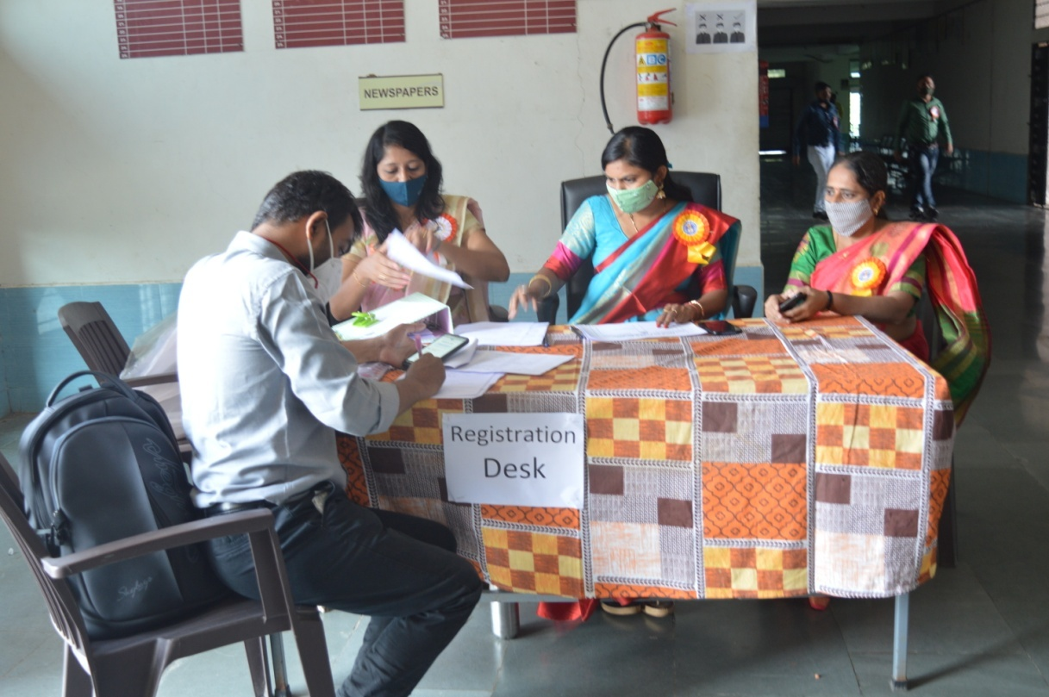
Registration Desk
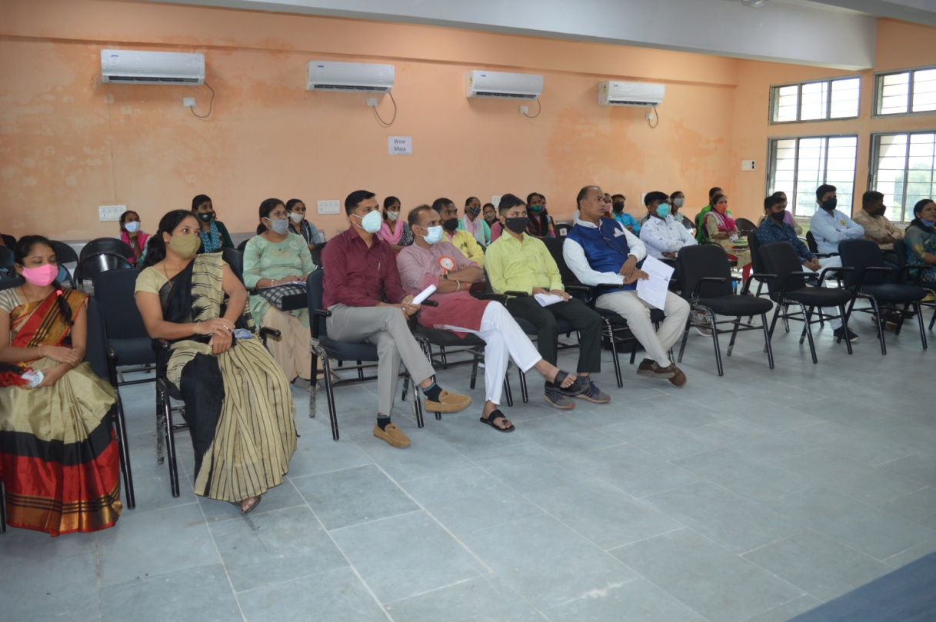
Participants
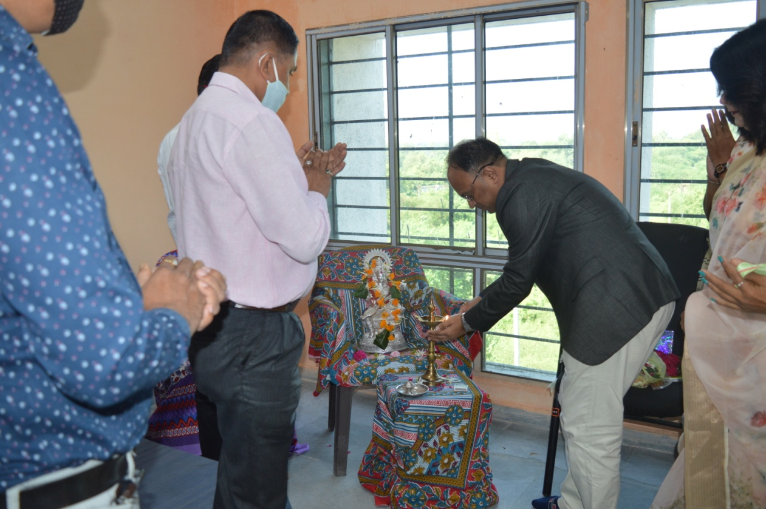
Lamp Lighting
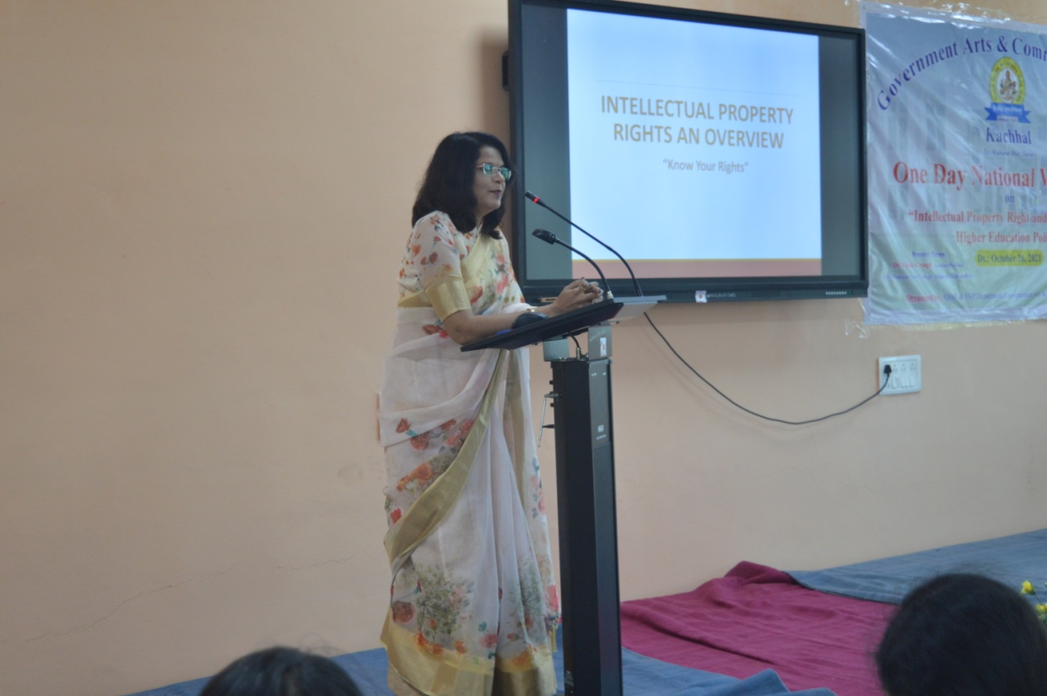
Dr. Vijeta S. Singh, Technical Session 1 (Intellectual Property Rights)
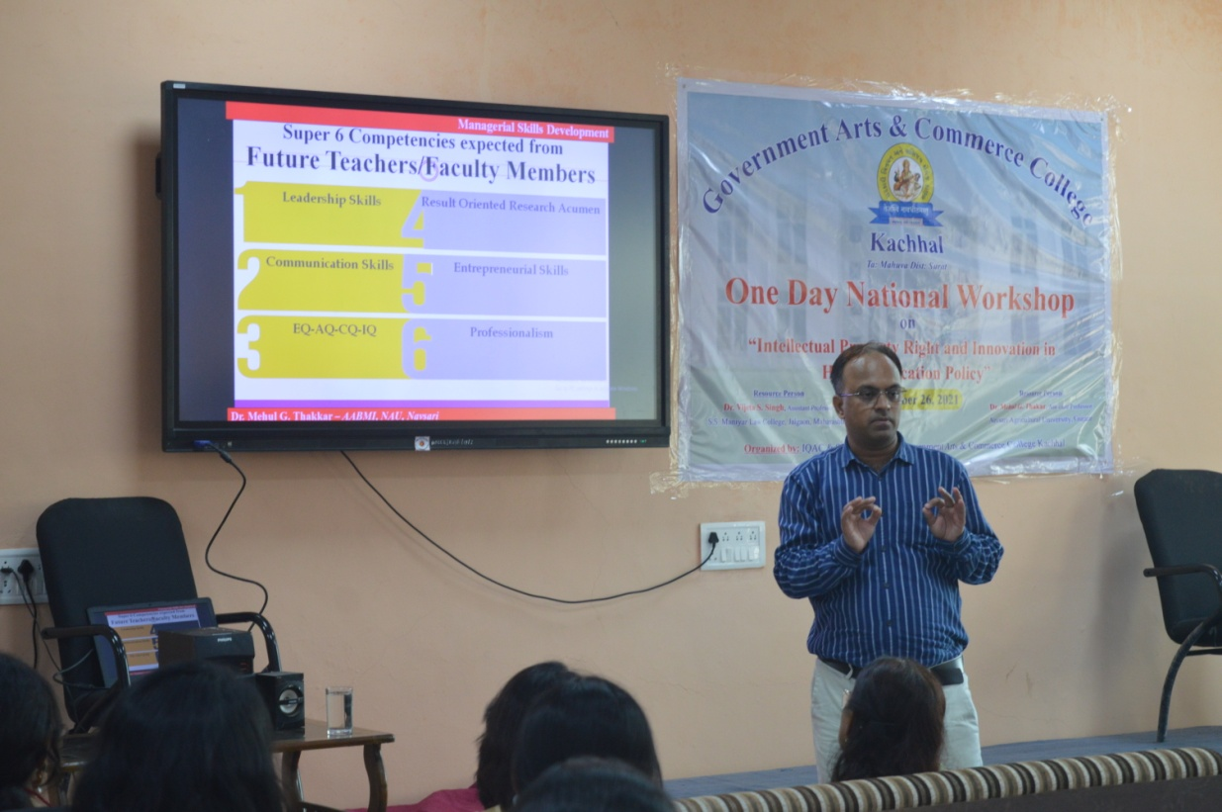
Dr. Mehul G. Thakkar. Technical Session 2 (Innovations in Higher Education Policy)
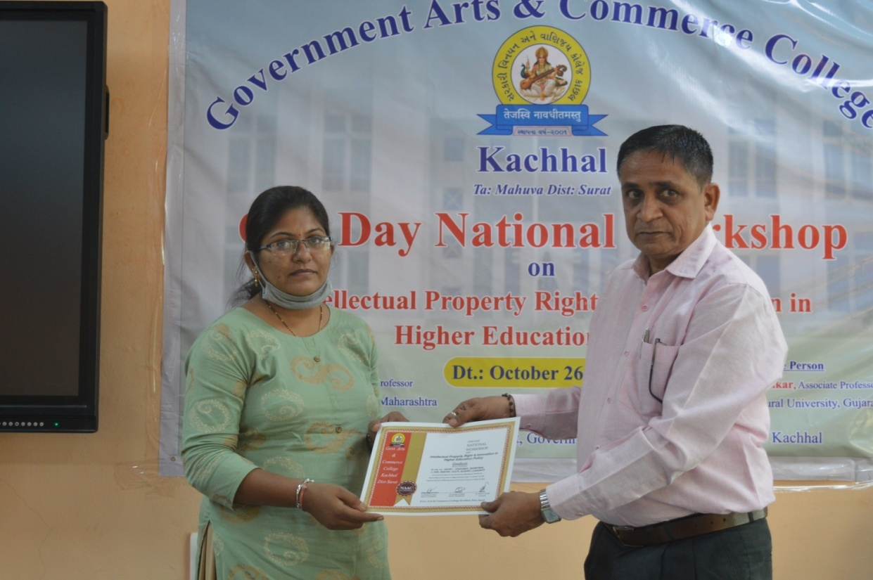
Certificate Distribution Ceremony
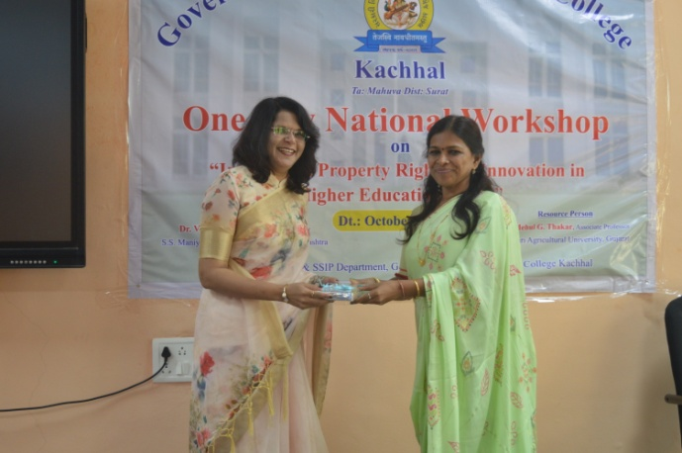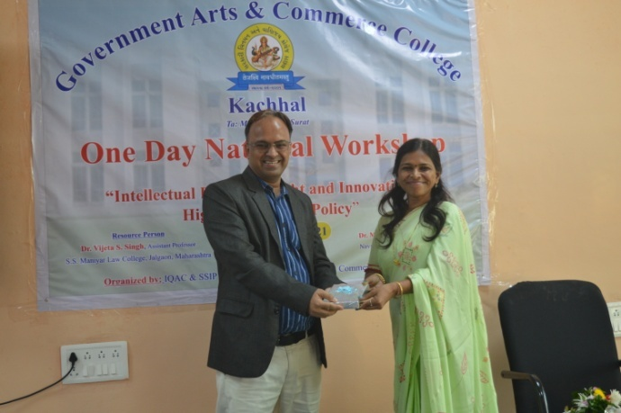
Principal of GACC Kachhal Dr. Hetal S. Tandel presenting mementos to resource persons
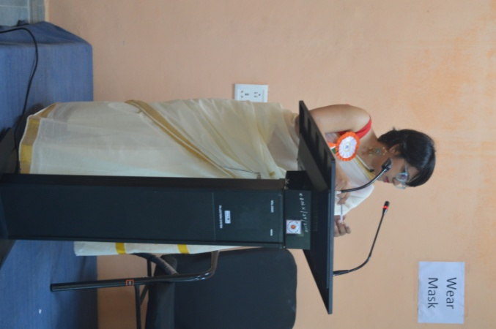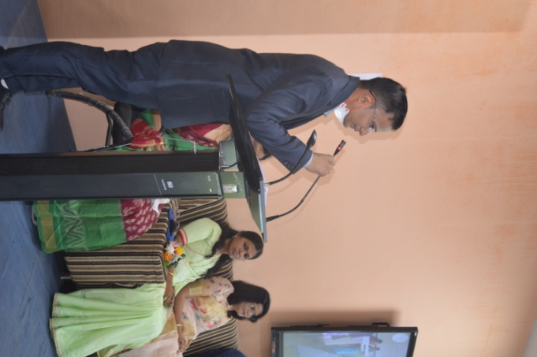
Anchor, Dr. Foram Chandarana Convener, Dr. Gunjan Shah
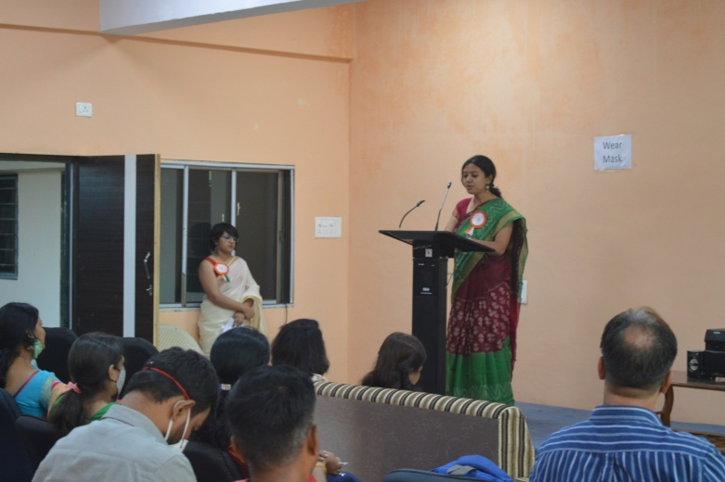
Organizing Secretary, Dr. Dhvani Desai

