**GOVERNMENT ARTS, COMMERCE & BED COLLEGE, KACHHAL**

**AT: KACHHAL, PO:KARCHELIYA, TA: MAHUVA, DIST.: SURAT, 394240**

**(Permanent Affiliated to Veer Narmad South Gujarat University, Surat)**

**NAAC ACCREDIATED: GRADE-C**

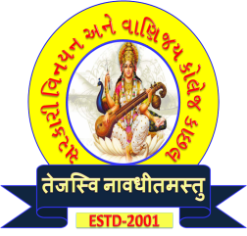

**Principal**

**Dr. Hetal S. Tandel**

**GES Class - 1**

**Mo. No. 98792 96636**

**Email: gacckachhal@gmail.com**

**Web Site: http://www.kachhalcollege.org/**

**INTERNAL QUALITY ASSURANCE CELL**

**AGENDA FOR IQAC MEETINGS TO BE HELD DURING THE YEAR 2021-22**

To,

All the IQAC Members are requested to go through the agenda set for IQAC meeting no. 3 to be scheduled on January 18, 2022 at 01:00 pm in the Principal’s office.

**Agenda:**

1. Submission of Academic Calendar
2. Preparing tentative schedule to conduct subject-wise seminars
3. Details of financial support available to faculty members for attending seminars and conferences.
4. Requirement of LAN wifi in lab
5. Discussion and planning any other matter with the permission of the chairperson.

Kindly make it convenient to attend the meeting.

Dr. Dhvani B. Desai Dr. Hetal S. Tandel

(Coordinator) (Chairperson & Principal)